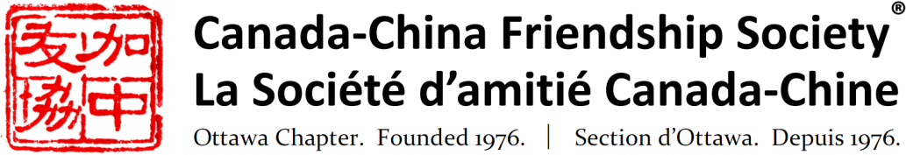
Patrons
Honourable Sheila Copps
Ambassador Robert Wright

Invitation to a Presentation

Canada-China Agricultural Cooperation:
Past, Present and into the Future
Peter Chen
Former Counselor, Canadian Embassy in China

Tuesday, April 23, 2019

7:30 p.m.

Knox Presbyterian Church

Geneva Room
120 Lisgar St, Ottawa
(corner of Elgin Street)

Please use side entrance on Elgin Street. Accessible.
Free parking at nearby City Hall Underground Garage.

Refreshments and conversation following the presentation
Everyone is welcome.*

Over the past several decades, Canada and China have co-operated in agriculture and food trade despite some recent turbulent events in the bilateral political relationship. Dr Peter Chen will highlight some past examples, share his observations and reflect on the factors which have contributed to success. He will also consider constructive approaches to maintain cooperation in a long-term perspective.

Dr. Peter Chen worked on Canada-China agriculture trade access and development for 15 years and has participated in trade access negotiations for Canadian canola and lumber/logs exports to China. He was twice posted to the Canadian Embassy to China as the agriculture and forestry counselor. Over his career with Agriculture and Agri-Food Canada, Canadian Food Inspection Agency, Dr. Chen served as a Deputy Director, Canada-China Trade Relationship, and participated in discussions relating to China's accession to the World Trade Organization (WTO).

*No pre-registration required. Entry is free for CCFS members and $10 for non-CCFS members. Tickets are available at the door or at Eventbrite: Eventbrite . Memberships are available at the door or at www.ccfso.org . Annual membership is $25 for individuals, $40 for a family of 2, $15 for students. For further information about the Society or this event, please consult our web site or www.facebook.com/ccfs.ottawa, write to ccfs.ottawa@gmail.com or phone 613-729-3660.

