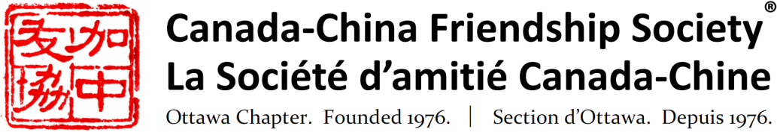

***Patrons***

***Honourable Sheila Copps***

***Ambassador Robert Wright***

|  |  |
| --- | --- |
| |  | | --- | | Event Notice: Tuesday, September 24 at 7:30 p.m. **Mark Kruger, formerly at Bank of Canada** **The Trade War and**  **China's Medium-Term Prospects**  As a result of demographic shifts and the accumulation of significant financial liabilities, China needs to change its growth model. It can no longer rely on increasing inputs to drive its growth but needs to find ways to use its existing resources as efficiently as possible. In short, China must increase its productivity and raise domestic value added. While there are signs this is occurring, China's progress could be derailed by the trade war. In this presentation, Mark will discuss the factors that are leading China to reorient its economy, assess progress to date and analyse the risks associated with the trade war. | |

|  |  |  |  |
| --- | --- | --- | --- |
| |  |  |  | | --- | --- | --- | | |  | | --- | |  |  |  | | --- | | Mark began his career at the Alberta Petroleum Marketing Commission in Calgary, Alberta in 1982. He joined the Bank of Canada in 1989 as an economist in the Monetary and Financial Analysis Department. He moved to the International Economic Analysis Department in 1992, where he held a number of positions including Assistant Chief responsible for international financial policy and emerging market issues. He served as a Senior Advisor to the Canadian Executive Director at the International Monetary Fund from 2003 to 2006. From 2006 to 2013, Mark headed the Economic and Financial Section in the Canadian Embassy in Beijing. In September 2013, he returned to the Bank as a Senior Director in the International Economic Analysis Department. In June 2019, Mark retired from the Bank and began to work as a Shanghai-based consultant on economic and financial issues related to China. |   **Mark Kruger** |   **Tuesday, September 24 - 7:30 p.m.**  **Christ Church Cathedral** 414 Sparks Street, Ottawa (between Bay St. and Bronson Ave) Free parking on site off Sparks St., handicapped access  All are welcome. No pre-registration required. Entry is free for CCFS members and $10 for non-CCFS members. Tickets and membership are available at the door.  For more information please visit  [www.ccfso.org](http://www.ccfso.org/" \t "_blank), *[Y:Users:Y:Downloads:1486068820_038_001_facebook_social_network_android_material.png](https://www.facebook.com/ccfs.ottawa)[Y:Users:Y:Downloads:1486068824_038_003_twitter_social_network_android_material.png](https://twitter.com/CCFSO1)[Y:Users:Y:Downloads:1486068833_038_030_share_link_friends_send_android_material.png](http://www.ccfso.org/)[Y:Users:Y:Downloads:1486068844_038_029_share_link_friends_send_mail_android_material.png](mailto:contact@ccfso.org)*  email  [contact.ccfs@gmail.com](mailto:contact.ccfs@gmail.com) or call 613-729-3660. |

.

.